LASSO

Solve linear system Ax=b, where A and b are known and x is unknown.

Example:

GPS signal in time domain

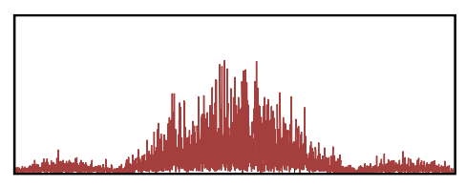

GPS signal in spectral domain

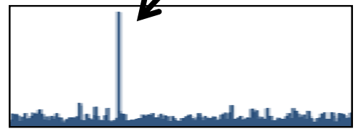

Case 1: A is invertible => Done, x = A-1b

Case 2: A is overdetermined => min |Ax-b|2

Case 3: A is underdetermined => Solution is nonunique!

If x is too complex: then it might be overfitting

We want x such that:

(1) Ax≈b

(3) x is simple

We have seen it in SVM, but this time we want |x|0 to be small. (Sparse recovery)

|x|0: number of nonzero components

min |Ax-b|2

s.t. |x|0 < t

Q: What's the problem?

A: It is non-convex!

Two relaxations

(1) l1 norm, aka Lasso regression

min |Ax-b|2

s.t. |x|1 < t

(2) l2 norm, aka ridge regression

min |Ax-b|2

s.t. |x|2 < t

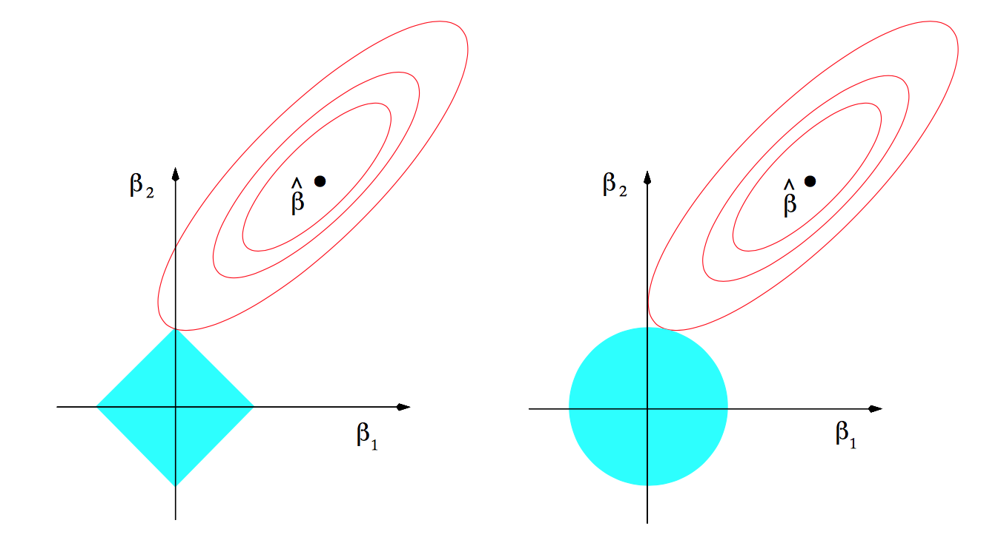

min |Ax-b|2+λ|x|1

Tuning the parameter λ to achieve different sparsity level